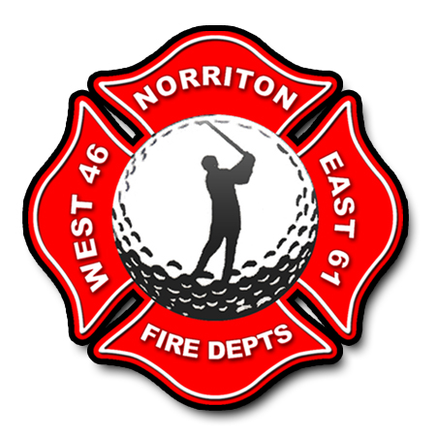
East/West Norriton Fire Companies Golf Outing

2025 Hole Sponsor / Corporate Sponsor

Company Name:_______________________________________________

Address:______________________________________________________

Phone Number:________________________________________________

Contact Name:________________________________________________

Email Address: _______________________________________________

Check Number:_________________ Amount: $________________

Hole Sponsor_______ Corporate Sponsor_______

Any Questions Call (610) 539-3990 Jefferson Fire Co No. 1

